Buying things in prison

Unit 1
Buying from a catalogue

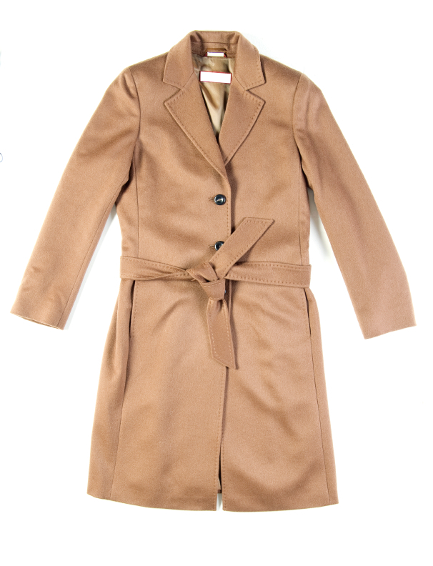
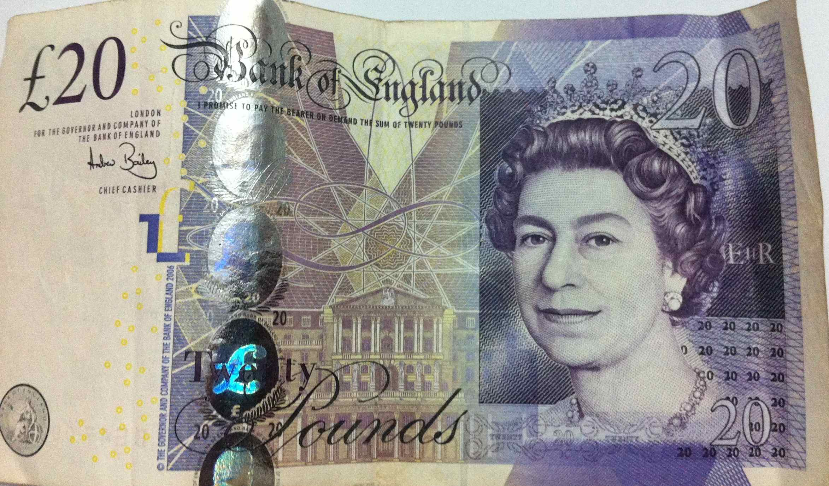

Contents

Unit 1 Buying from a catalogue teacher’s notes

Unit 1 Buying from a catalogue learner resources

Unit 1 Buying from a catalogue answers

Overview
Unit 1 Buying things in Prison teacher’s notes
This unit focuses on prisoners making purchases from catalogues with their private money and provides the opportunity to build vocabulary relating to formal language and clothes. It includes some practical form filling and letter writing practice with a focus on grammar, punctuation and spelling. Key language is presented in practical worksheets with a focus on what is required in prison to make purchases, and how to make formal requests to governors. Learners will use this language by writing their own formal letters to the governor and filling in a prison style form for catalogue purchases.
Time: 90 minutes plus extensions.

Level: Entry level 1-3 / Scottish Nati 2 – National 4 / CEFR A1 – B1

Aims
For all learners:
- to introduce /revise language used in catalogues and to do with clothing from
- to improve spelling of clothing items
- to promote better communications between learners and staff with a better understanding of formal language and requests.

Entry 2 and above
- to develop vocabulary used in formal contexts
- to develop detailed reading skills in the context of catalogues and forms
- to use authentic forms to develop form filling skills
- to develop grammatical structures used in formal letters of request.

Objectives
All learners will be able to:
- fill in an application form for personal purchases
- use a wider range of vocabulary to request personal purchases of clothing e. g. ‘I would like to buy a coat’
- read and understand a prison order form for special purchases
- write a simple formal letter of request.
Some learners will be able to:
- write detailed formal letters of requests with relevant grammar, punctuation and spelling.

Preparation
You will need:
- Resource 1a – one for each learner.
- Resource 1 b – one cut up for each learner at Entry 1/2
- Resource 2 – one for each learner. You could cut it into 3 parts and just give the first task to learners at lower levels.
- Resource 3a for learners at lower levels, 3b for learners at Entry 2/3, 3c for higher levels
- Resource 4 - one for each learner.
- Resource 5 - one for each learner
- Resource 6a - cut-up for all learners
- Resource 6b – one copy for each learners at Entry 1 / 2
- Catalogues and apps for ordering catalogue items used in your prison
- Scissors or cut up before the session.

Suggested Procedure

Warmer
- Initiate class discussion about the clothes they are wearing to elicit vocabulary of clothing.
Activity 1 – Vocabulary development
- Hand out resource 1a, focus learners on the model answers and ask why there is a line between the words and the pictures.
- Ask learners to label the pictures.

Differentiation
- For learners at lower levels, cut the names of the clothing from resource 1b into individual labels that they can either place on the items of clothing in the images or copy them and draw a line to the appropriate picture.
- You may want to give fewer labels to learners with limited literacy.
- Learners at Entry 3 could label the items independently without looking at resource 1b. You could also challenge fast-finishers to think of alternative names for items eg jumper/sweater/woolly

Activity 2 – Grammar and spelling
- Either hold up an image of an article of clothing eg jumper, apron, trousers, or an actual item and elicit what the item is. Nominate a learner to spell the word and write it on the right of the board. Pause if they give you the wrong letter and support them to decide on the correct one.
- Next elicit the article that goes with each word. You could do this by using it in a short sentence pausing where the article goes eg ‘I need ___ apron’ ‘I buy trousers from…’
- Discuss articles a/an/Ø.
- Hand out resource 2 and check that learners know what the items on the sheet are.
- Ask all learners to complete task 1 and then check their answers with a partner at the same level. Nominate learners in turn to give the answer to each item. Ask if everyone agrees.
- Learners could then do the next task and compare their answers with a partner, or in groups of three.
- Fast finishers could complete the third (spelling) task.
- Display the table on the Interactive White Board (IWB) if you have one read out each item and nominate a learner to give the answer.
- Check that everyone agrees to identify learners who need further help.

Tip – all learners will be able to complete part, if not all, of this worksheet as the vocabulary has already been provided.
Activity 3 – language in catalogues
- Initiate class discussion: ‘How can you order items that are not on the canteen sheet?’
- Elicit the process from learners who are familiar with it. Write each step they need to follow on the board to support learners who are not familiar with the process, checking understanding as you do so.
- If you have been able to get copies of the catalogue/s available in your establishment, hold one up and elicit what it is, its purpose and if they have ever used it. Tell them if they don’t know.
- Do the same with the ‘app’ they need to use to order items.
- Concept check understanding of the function of catalogues and apps by asking these questions:
  - ‘What is in this (indicating the catalogue)?’ (Possible answers: ‘A book with things you buy,’ ‘Pictures and information about things you can buy.’)
  - ‘Why do you look in this?’ (Possible answer: ‘To order things you want/ need.’)
  - ‘How do you order things from the catalogue?’ (Possible answer: ‘You need to fill in an / the app.’)
- If you have multiple copies of the catalogue ask learners, in pairs or small groups of three or four, to open a page with various text features.
- Draw their attention to these features highlighting key terms and abbreviations such as sizes, order numbers, descriptions. Ask questions like ‘I want to buy a jumper – ‘where can I find it? How much does it cost?’ Make sure you cover all the vocabulary in resources 3a and b.
- Then hand out resource 3a or 3b to learners according to their level (3a is lower level) and model the first answer for each group. Allow learners to complete the questions independently, monitoring and supporting where necessary..
- Ask learners to compare their answers with a partner at a similar level, then go over them as a group, nominating learners to give the correct answers.

Differentiation
- You may need to work with learners with literacy needs and just do the first task on resource 3a, while the others work independently or in mixed ability pairs.
- Fast finishers can do task 3 on resource 3b

Activity 4 – form filling
- Ask learners what 3 pieces of information they must always put on an application form
  - full name
  - prison number
  - wing
- Hand out resource 4 and go over the model answer. Ask questions to check understanding e.g. What’s the first thing on the form?’ (Possible answer: ‘Jeans’)
- Elicit what ‘official use’ means and that they shouldn’t write on this part,
- Learners complete the task by ordering up to four items from resource 3a, with those at the lower levels ordering just one item with your, or a more advanced learner’s support.
- Learners can check each other’s order forms for accuracy.
Tip – this could be used as an addition task for totalling the order and focusing on the pronunciation of money/numbers.

Differentiation
Learners at lower levels can fill in the form in pairs taking it in turns to write and helping each other.

Activity 5 – formal letters
- Sometimes prisoners have to write a letter to the governor to request permission to purchase certain items.
- Elicit what learners know about the language used to write an informal letter to a friend and how that is different from what they would use in a formal letter.
- Discuss items or requests that would require special permission in your prison while eliciting formal and informal language. Write their suggestions on the board under the headings ‘formal’ and ‘informal’. If necessary suggest examples to them e.g. ‘hi’ ‘ok’ ‘love’ ‘cheers’ ‘ta’ ‘dear’ ‘sir’ ‘sincerely’ and so on.
- Ask what else they should consider e.g. grammar, spelling, punctuation, no expletives, neat writing.
- Establish that they understand that they would have to write a formal letter to a governor.
- Hand out resource 5 and discuss formal language for writing to a governor. Check all learners understand the meaning of the words in the boxes.
- Allow learners time to complete the vocabulary exercises.

Activity 6 – reconstructing a letter
- Tell the learners that they are going to reconstruct a letter from Mustafa to a governor, to ask permission to buy a coat with the money in his personal spends account. Give the phrases and sentences cut up from resource 6a to learners to reconstruct the letter.
- Give all the phrases to the more advanced learners and tell them that three of the phrases which should not be included in the letter. Give learners at lower levels only the correct phrases.
- Ask them to compare answers. Monitor and support noting any issues to come back to.
- Ask learners to write a letter to the governor requesting permission to buy items requiring special permission.
- Encourage peer correction – learners check each other’s letters and underline any words or phrases they think are wrong. Monitor and support to ensure the correct formalities are used.
Tip – if there are no items requiring permission in your prison, write the letter anyway to practise formal writing.
Differentiation
Learners at lower levels could complete the resource 6b formal letter, gap fill exercise. They can use it as a model to write their formal letter.
Higher level learners can write a more detailed letter to include conjunctions such as: therefore, although, as; but, for example. Grade the conjunctions used according to your learners’ levels. List the conjunctions on the board and elicit when to use each one and ask learners to use as many as they can (or specify a number) in their letter.
Follow-up or extension activities
Activity 7 – Error correction
- Hand out resource 7a (higher level) and 7b (lower level) for learners to find the mistakes in grammar, punctuation, vocabulary or spelling.
- Lower level learners could be instructed to find the vocabulary in the text to match the pictures at the bottom of the sheet.
- You could allow all learners to attempt the whole text and differentiate by the numbers of mistakes they are expected to find. This is not an exact science and allows lower level learners to be motivated to find as many as they can.
- This could be used as a spring board activity to focus on punctuation, spelling or grammar issues that become apparent from this task. For example, if there is a lack of understanding about short forms in formal letters, this could be an opportunity to build on short forms, or if there is a lack of understanding about commas, this could be built upon.
Cooler Vocabulary bingo.
The vocabulary used is from the lesson and paired with a minimal pair to practise spelling, pronunciation and listening skills. Depending on the time remaining you can focus more or less on the pronunciation and listening skills.
- Give the 8 bingo cards to hand to individual students.
- If you have more than 8 students, two learners can share a copy.
- One learner to call the words one at a time, for the listener to mark off on their card.
- Once a learner has completed a line in any direction: vertical, horizontal or diagonal, they win.
- The winner then calls the words in the next game.
Tip – if learners mark the card in pencil they can rub out the marks and use the same card again. Or you can cut up counters to put over numbers called out.

Resource 1a clothing vocabulary
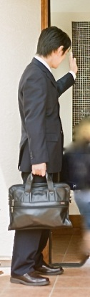
coat


jeans

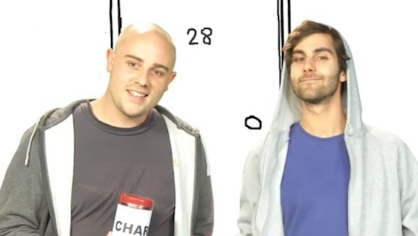
Resource 1b clothing vocabulary

jacket | coat
jeans | suit
tie | bag
trousers | shirt
t-shirt | jumper
shorts | trainers
long-sleeved | short-sleeved
hooded jacket | sweatshirt
shoes | scarf
cardigan | belt

Resource 2 Articles and spelling
We use:
a – when we are talking about an item starting with a consonant
an – when we are talking about an item starting with a vowel
Ø – no article when we use a plural
a jumper an apron trousers

Now put a, an, Ø, into the following list.

1a) A_ t-shirt b) ___ jeans c) ___ umbrella
d) ___ hoodie e) ___ shirt f) ___ shoes
g) ___ suit h) ___ apron i) ___ tie

2) Match the word with the picture. Use the correct article.
a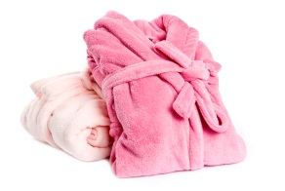b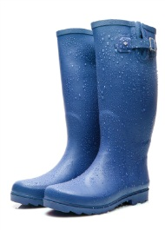c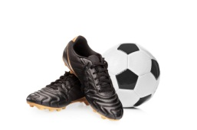de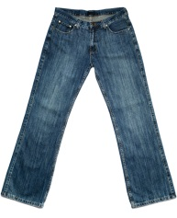f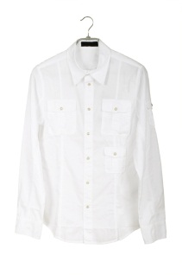
football boots tie shirt jeans dressing gown wellington boots (wellies)

3) Put the letters in the correct order to spell the names of clothes.
a) ssoeh shoes b) tosob ________
c) gdesrsni owgn _______________ d) eti ________
e) tolafobl tsobo _______________ f) riths ________
g) leweisl _______________ h) nejas ________
i) tiksr ________________ j) kajcte ________

Resource 3a vocabulary in catalogues

There is a lot of information in a catalogue.
When they describe things they use a lot of short words. We call these short words, abbreviations.
Take a look at some examples below to see what they mean.

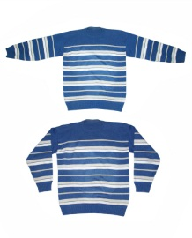 | Product summary  Striped design jumper, front and back.  - Available in sizes XS, S, M.  - Composition: 100% cotton.  - Machine washable at 40°C  - PON: 589632  - Price: £9.99 | Description  Size  Product number  Price

Match the information needed on the left, with the information on the right.

1 Product number medium
2 Description PON456258
3 Size grey cotton jumper
4 Unit cost £9.99

When they describe clothes they can be XS, S, M, L, XL, XXL. X means extra, S means small, L means large.

Can you match the size with the abbreviation?
5 large XS
6 Small XL
7 Extra small M
8 Extra large XXL
9 Medium S
10 Extra extra large L

Resource 3b vocabulary in catalogues

When you want to order something from a catalogue, you need to give lots of details.
What details do you think you will need?



Product summary
Striped design jumper, front and back.
- Available in sizes XS, S, M.
- Composition: 100% cotton.
- Machine washable at 40°C
- PON: 589632
- Price: £9.99

Description
Size
Product number
Unit cost

Match the information needed on the left, with the information on the right.

1 Product number medium
2 Page number £9.99
3 Description PON456258
4 Size grey cotton jumper
5 Quantity 101
6 Unit cost £18.98
7 Total cost 2
Some items do not need all of this information. If you are ordering a tie, there will not be a size.

8 When the information is not in the catalogue, what would you put on the form?
a) Nothing
b) Make up a size
c) n/a
9 What do you think n/a means?

The vocabulary we use when we are talking about size is different, depending on the item.
Shoe sizes can be size 4 – 14(UK), or 37 – 48(EU)
Clothes can be small, medium, large, extra-large, or in inches or centimetres.

10 What do S, M, L, XL, mean when talking about size?
11 What does W34, L36 mean when talking about a pair of trousers?
12 Is the measurement in inches or centimetres in question 11?
Resource 3c vocabulary in catalogues

There is a lot of information in a catalogue.
When they describe things they use a lot of short words. We call these short words, abbreviations.
Take a look at some examples below to see what they mean.

 | Product summary  Striped design jumper, front and back.  - Available in sizes XS, S, M.  - Composition: 100% cotton.  - Machine washable at 40°C  - PON: 589632  - Price: £9.99 | Description  Size  Product number  Price

Match the information needed on the left, with the information on the right.

1 Product number medium
2 Description PON456258
3 Size grey cotton jumper
4 Unit cost £9.99

When they describe clothes they can be XS, S, M, L, XL, XXL. X means extra, S means small, L means large.

Can you match the size with the abbreviation?
5 large XS
6 Small XL
7 Extra small M
8 Extra large XXL
9 Medium S
10 Extra extra large L

Resource 3c vocabulary in catalogues

Here is an example of a page from a catalogue that you can order from in prison. Take a look, and answer the questions.
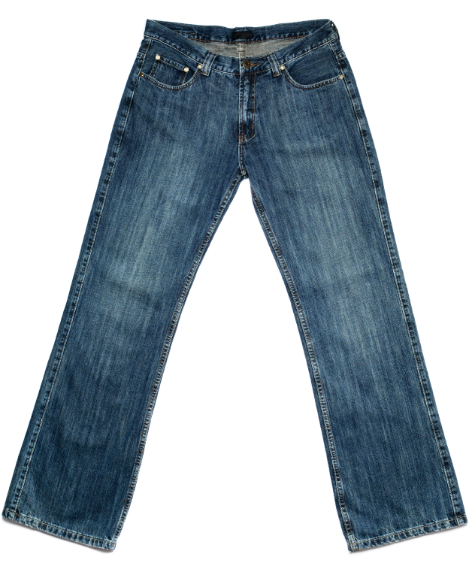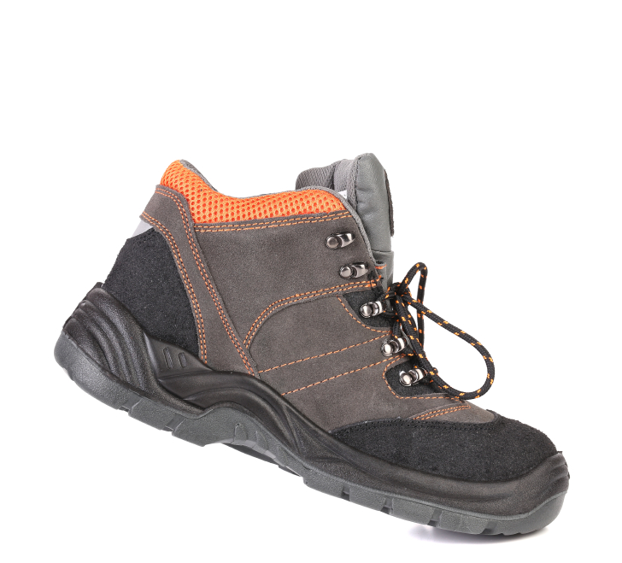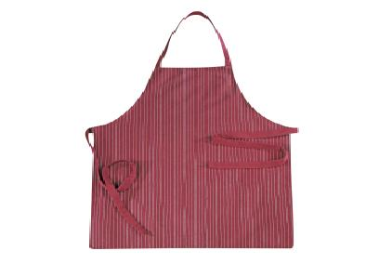

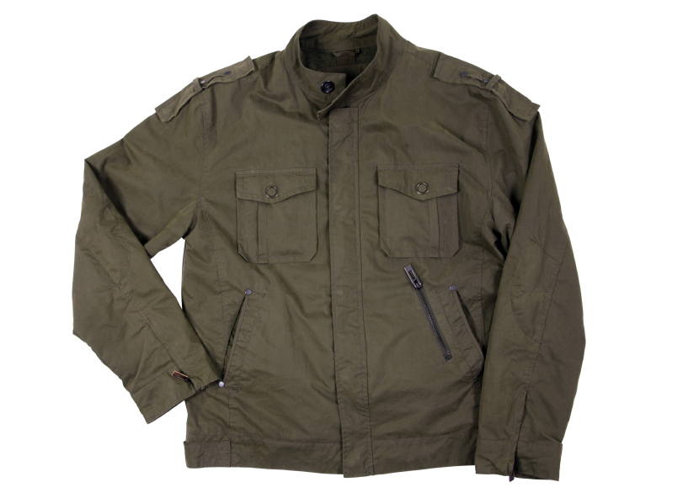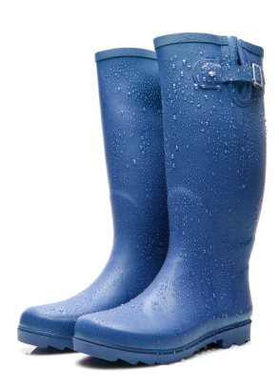

199

Product summary
This cotton apron has an adjustable neck for your comfort and will protect your clothing when cooking.
Red cotton apron.
- Adjustable neck.
- Size W76, L85cm.
- PON: 789456
- Cost: £10

Product summary

This butchers style cotton apron has an adjustable neck for your comfort and will protect your clothing when cooking up a storm.
Blue cotton apron.
Adjustable neck.
Size W76, L85cm.

Product summary

Classic and fresh work shoe. These high top work shoes come in brown and black.
- Composition: Outer: other. Inner: other. Sole: other.
- Size: 6-15
PON: 123852
Cost: £40

Product summary
Indigo Sandblast jeans.
Composition: 100% cotton.
- Machine washable at 40°C.
- Size: S, M, L
PON: 123852
Cost £20

Product summary
Men's waterproof jacket. Stylish and comfortable.
- Available in sizes: small.
- 100% polyester with PVC coating. Lining: 100% polyester.
- Machine washable at 40°C.
- PON: 741456
- Cost: £30

Product summary

Wellington boots.
- Composition: Outer: other. Inner: textile. Sole: other.
- Wipe clean.
- Available in sizes: 5 to 9.
- PON: 2586010
- Cost: £15

Product summary
Designed in London. If you're feeling the chill, this hoodie is perfect. It comes in a chic charcoal or light grey.
- Available in sizes S, M, L, XL.
- Composition: 60% cotton, 40% polyester.
- Machine washable at 30°C.
PON: 963258
Cost: £25

- What is the page number for the wellies? ___________________________________
- What size is the jacket? _________________________________________________
- Can you order the apron in blue? _________________________________________
- Can you get the jeans in extra-large? ______________________________________
- What word means the material that the item is made from? _____________________
- How many colours is the hoodie available in? ________________________________
Resource 4 form filling in prison

Full name ______________________ prison number ________________________ wing _____________________________
To Be Completed By The Prisoner |  |  |  |  |  |  |  | Official Use Only
 | Supplier  I.e. Argos, M&M | Full catalogue number | Page number | description | Size | Quantity | Unit cost  (£) | Total cost  (£) | Approved by stores | Money deducted by finance | Item received
1 | Argos | PON: 123852 | 199 | Indigo sandblast jeans | small | 1 | £20
2
3
4
5
Postage and administration fee |  |  |  |  |  |  | £1.00
Total cost of order (incl above fees)

Signed ___________________________________ Date submitted __________________________________________

Resource 5 formal language in letters

When we write letters to our friends we use informal language.
When we write letters to solicitors, governors, councils, employers, we use formal language.

Do you know the difference between informal and formal language?
- Look at the list of words used in letters in list (a), and match them to the words with the same meaning in list (b).
(b)
can
Bye
want
Hi
tell
allow

(a)
Dear
Would like
request
suggest
permission
Sincerely

- Which list of words would you use in a formal letter: a or b? _________________
Below is an example of a letter written by a prisoner to his Governor, to request extra gym sessions.
- Do you think this is a good letter? _____________
- Why/why not? _____________________________________________________
A1234NY
B. Abdul
HMP York
Governor Spa
HMP York
Dear Sir,
I would like to request permission to attend an extra gym session each week.
My health has not been good and health care suggest that it would be good for me.
I look forward to your reply.
Yours sincerely
B Abdul

Learner worksheet 6a
Activity 6 a– formal language in letters
Below is a letter Mustafa writes to a governor, to request permission to buy a coat with the money in his personal spends account.

- Three of the sections are wrong, which three are they?
- Why are they wrong?

Dear Governor Simms, | Hi governor,
but I get very cold walking around the grounds. | to buy a new coat
with the money in my personal spends account. | I would like to ask permission
and I get very cold walking around the grounds. | A44444AN
There is enough money in my account | Thank you
The weather is getting cold now that winter is here | Thanks mate
because my family sent some in to me. | Yours sincerely
 | Mustafa Abdul

- Now write a letter to your Governor, requesting permission to buy something from a catalogue. You can write it on the back of this worksheet.

Resource 6 formal letter: gap fill.
Complete the gaps in the letter below with the words in the box, to make a formal letter.

Dear Governor,

The (a)__________________ is getting cold now, (b)_____ I would like to buy a coat to keep warm.
I have money in my (c) ____________ account that I would like to use.

(d)__________ can I have your (e) _______________ to buy this.

Yours (f)__________________

Chiko Farah
(g)_____________

Governor spends and Please
weather permission A1199AN

Resource 7a
Activity 7a – find the mistakes
There are a lot of mistakes in the letter below. Read it and mark the mistakes with g for grammar p for punctuation, s for spelling and v for vocabulary

How many mistakes can you find?

Hi governor

I am a enhanced prisoner in this prison, and have been enhanced for 2 years. This is because I am a very good person and keep out of truble.
Because I have been in prison a long time, I need new clothes. I have £500 in my spends’ account which I would like to use.
The clothes I want to buy are for the winter. It is geting cold now and I need a new coat. My last one got nicked when I was in my last prison.
I want new trainers because the ones I have are worn out, they have a hole in the soul. Also I would like new underwear because mine is horrid. It’s been washed so many times that it is falling apart. So, I would like new pants and some vests for the winter, to keep me walm
Finally, I would like to buy some new jumper. All my jumpers were ruined in a fawlty washing mashine so now I do not have any, therefore I would like to buy some more.

Thank you for reading my request and I look forward to your reply.

Yours Sincerely

Atif Yassim
A3698AN

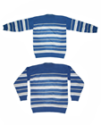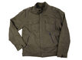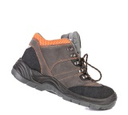
v

Resource 7b – find the mistakes

- Hi governor

- I am a enhanced prisoner in this prison. I am very good person and keep out of trouble.
- I have been in prison a long time, I nid new clothes.
- I have £500 in spends’ account which I can use.
- I want to buy clothes for the winter. It is geting cold now and I need a new coat.
- i need new trainers because mine are worn out.
- Also I would like new underwear because mine is horrid.
- I would like new pants and some vests for the winter, to keep me walm
- I want buy some new jumper. All my jumpers were ruined in a faulty washing mashine so now I do not have any.
- Thank you for reading my request and I look forward to your reply.

- Yours Sincerely
Atif Yassim
A3698AN

Can you spot the mistakes?

Line 1 1 vocabulary and 1 punctuation mistake
Line 2 2 grammar mistakes
Line 3 1 spelling mistake
Line 4 1 grammar mistake
Line 5 1 spelling mistake
Line 6 1 punctuation mistake
Line 7 1 vocabulary mistake
Line 8 1 spelling mistake
Line 9 2 grammar mistakes and 1 spelling mistake
Line 11 1 punctuation mistake



Learner worksheet 9
Activity 8 – vocabulary bingo, minimal pairs
Cut/tear out the 8 cards to hand to individual students.

shirt | tie | short
shoes | choose | lie
lose | jeans | cost
lie | tie | short
shoes | choose | shirt
cost | jeans | beans

shirt | tie | short
shoes | lost | lie
lose | choose | beans
shirt | tie | short
beans | choose | lost
lose | jeans | shoes

shirt | short | tie
shoes | choose | lie
lose | jeans | beans
shirt | tie | short
lose | choose | lie
shoes | jeans | beans

beans | tie | short
shoes | choose | lie
lose | jeans | shirt
shirt | lie | short
shoes | choose | tie
lose | jeans | beans

Unit 1 Buying things in prison answers
Resource 2
1) Ø c) an d) a e) a f) Ø g) a h) an i) a
2) dressing gown b) wellington boots (wellies) c) football boots d) tie e) jeans f) shirt
3) boots c) dressing gown d) tie e) football boots f) shirt g) wellies h) jeans i) skirt j) jacket
Resource 3a
Resource 3b
2) page number – 101 3) description – grey cotton jumper 4) size – medium
5) quantity – 2 6) unit cost - £9.99 7) total cost - £18.98 8) d 9) not applicable 10) small, medium, large, extra large 11) waist, leg 12) inches
Resource 3c
1) 199 14) small 2) no 3) no 4) composition 5) 2
Resource 5
1) Would like – want, request – can, suggest – tell, permission – allow, sincerely – bye
2) a
5) Dear Governor Simms,
I would like to ask permission/to buy a new coat/ with the money in my personal spends account./
The weather is getting cold now that winter is here/ and I get very cold walking around the grounds./
There is enough money in my account/ because my family sent some in to me./
Thank you./
Yours sincerely,/
Mustafa Abdul/
A44444AN/
6) Hi governor: but I get very cold walking around the grounds: thanks mate.
7) hi, informal: but, wrong conjunction: thanks mate, informal.
Resource 6
a) weather b) and c) spends d) please e) permission f) sincerely g) A1199AN
Resource 7a
Dear (v1 ) Governor (p1)
I am an (g1) enhanced prisoner in this prison, and have been enhanced for 2 years. This is because I am a (g 2) very good person and keep out of trouble(s1) .
Because I have been in prison a long time, I need new clothes. I have (g3) £500 in my spends account which I would like to use.
The clothes I want to buy are for the winter. It is getting(s2) cold now and I need a new coat. My last one was stolen (v2) in my last prison.
I would like (v3) new trainers because the ones I have are worn out, they have a hole in the sole (s3). Also, (p2 comma) I would like new underwear because mine is worn out (v4). It has (g4 ) been washed so many times that it is falling apart. So, I would like new pants and some vests for the winter, to keep me warm(s4).(p3 full stop after warm. )
Finally, I would like to buy some new jumpers (g5). All my jumpers were ruined in a faulty (s5) washing machine(s6), (p4 comma after machine) so now I do not have any and I would like to buy some more.
Thank you for reading my request, and I look forward to your reply.
Your sincerely(p5)
Atif Yassim
A3698AN

Resource 7b
- Hi governor / Dear Governor

- I am an enhanced prisoner in this prison. I am a very good person and keep out of trouble.
- I have been in prison a long time, I need new clothes.
- I have £500 in my spends account which I can use.
- I want to buy clothes for the winter. It is getting cold now and I need a new coat.
- I need new trainers because the mine are worn out.
- Also I would like new underwear because mine is worn out.
- I would like new pants and some vests for the winter, to keep me warm
- I want to buy some new jumpers. All my jumpers were ruined in a faulty washing machine so now I do not have any.
- Thank you for reading my request and I look forward to your reply.
- Yours sincerely

